2.2 Equation of Lines

Equations

An equation is a statement that two mathematical expressions are equal.

Which of the following are equations?

2 + 1
3 + 4 = 7 is an equation
x + 8 = 5 is an equation
x + 3

What do the equations have in common?
The two mathematical statements above are equations, because they have equal signs.

Solutions to Equations

To solve an equation means to find all the values of the variable that make the equation a true statement.
Such values are called solutions. Ex: The solution to x + 4 = 5 is x = 1
1+4 = 5 (substituting x = 1 into the equation gives you a true statement)
The set of all solutions is the solution set. Ex: The solutions for x² - 1 = 0 are x = 1 or x = -1. So the solution set is {-1, 1}.
1² - 1 = 0
(-1)² - 1 = 0
2² - 1 = 0 (This is not a true statement). This means that x = 2 is not a solution to x² - 1 = 0.
Solutions to an equation satisfy the equation. Can we verify that the solutions above are actually solutions?
Two equations are equivalent if they have the same solution set. Ex: x² - 1 = 0 and x² = 1 are equivalent equations.

Check if x = 3 is a solution to 5x - 2 = 7.

5(3) - 2 = 7 (This is not a true statement). x = 3 is not a solution to 5x - 2 = 7.

Types of Equations in One Variable

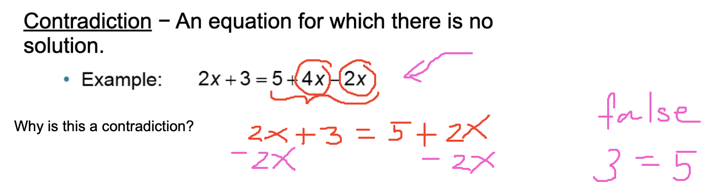

3 = 5 is a false statement. So the equation has no solution. When an equation has no solution, it is called a contradiction.

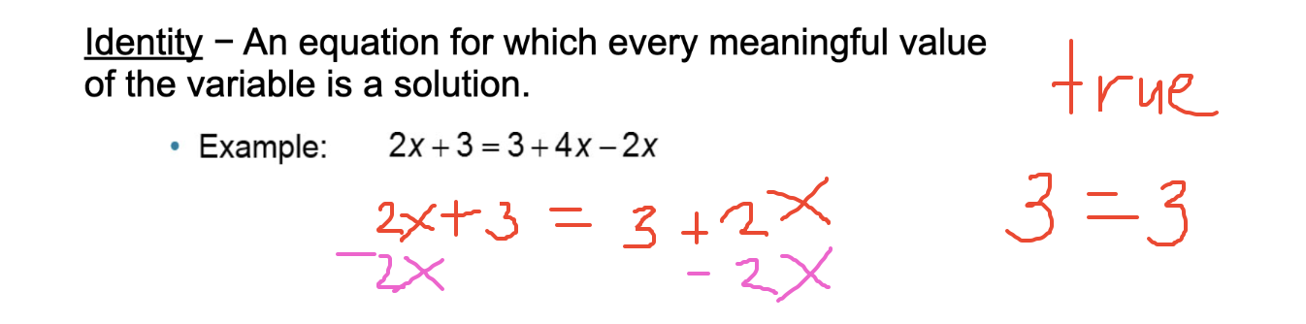

Why is this an identity?
The equation 2x + 3 = 3 + 4x - 2x is an identity, because no matter what x is, we will get a true statement.

x = 0. 2(0) + 3 = 3 + 4(0) - 2(0) => 3 = 3 (true statement) This means that x = 0 is a solution.
x = 1. 2(1) + 3 = 3 + 4(1) - 2(1) => 5 = 5 (true statement) This means that x = 1 is also a solution.

There are infinitely many solutions to this equation.


2x + 3 = 5 + 4x
-2x -2x

3 = 5 + 2x
-5 -5

-2/2 = 2x/2
-1 = x

x = -1 is the only solution to the equation

Why is this a conditional equation?
Since only one value for x makes the equation true, then the equation 2x + 3 = 5 + 4x is a conditional equation.

Given the equation 3x = 5x + 1. Is this equation an identity, a contradiction, or a conditional equation?

-2x = 1 => x = -1/2. Since we only have one solution to this equation, then 3x = 5x + 1 is a conditional equation.

Example
2x = 2x + 7
-2x -2x

0 = 7 (false statement). 2x = 2x + 7 will never be true. No value for x will make the equation a true statement. So that means that 2x = 2x + 7 is a contradiction.

Linear Equations in One Variable

A linear equation in one variable is an equation that can be written in the form
ax + b = 0,
where a and b are constants with a ≠ 0.
If an equation is not linear, then we say it is a nonlinear equation.

Which of the following are linear equations? Why?

x + 5 = 3 (linear)
y = 2x - 6 (linear)
y = x² + 7 (non-linear)
y² - x² = 1 (non-linear)

Properties of Equality
Properties of equality help us solve equations.

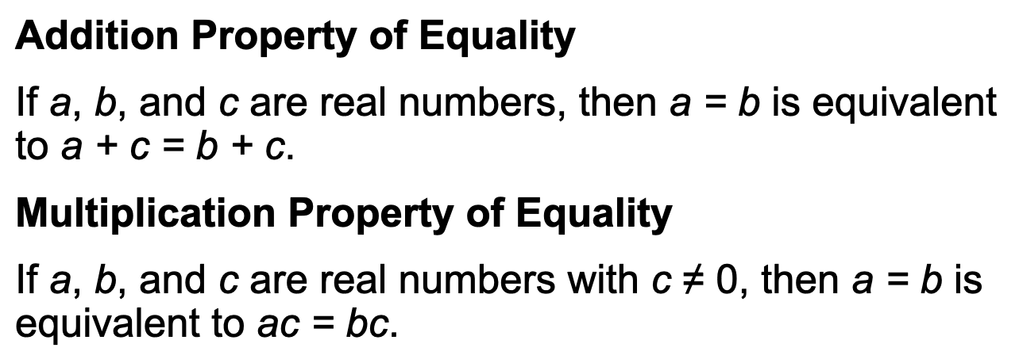

x = 5
x + 2 = 5 + 2
Adding two to both sides of the equation x = 5, means that the result (x + 2 = 5 + 2 is equivalent to x = 5)

(3)x =(3)5

x+7 = 5x - 9
5(x+7) = 5(5x-9)

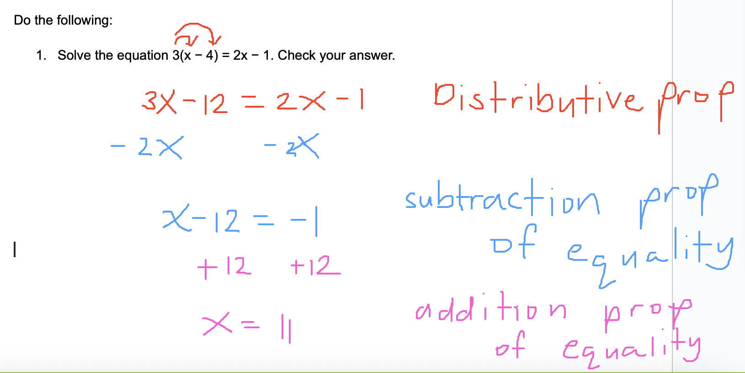
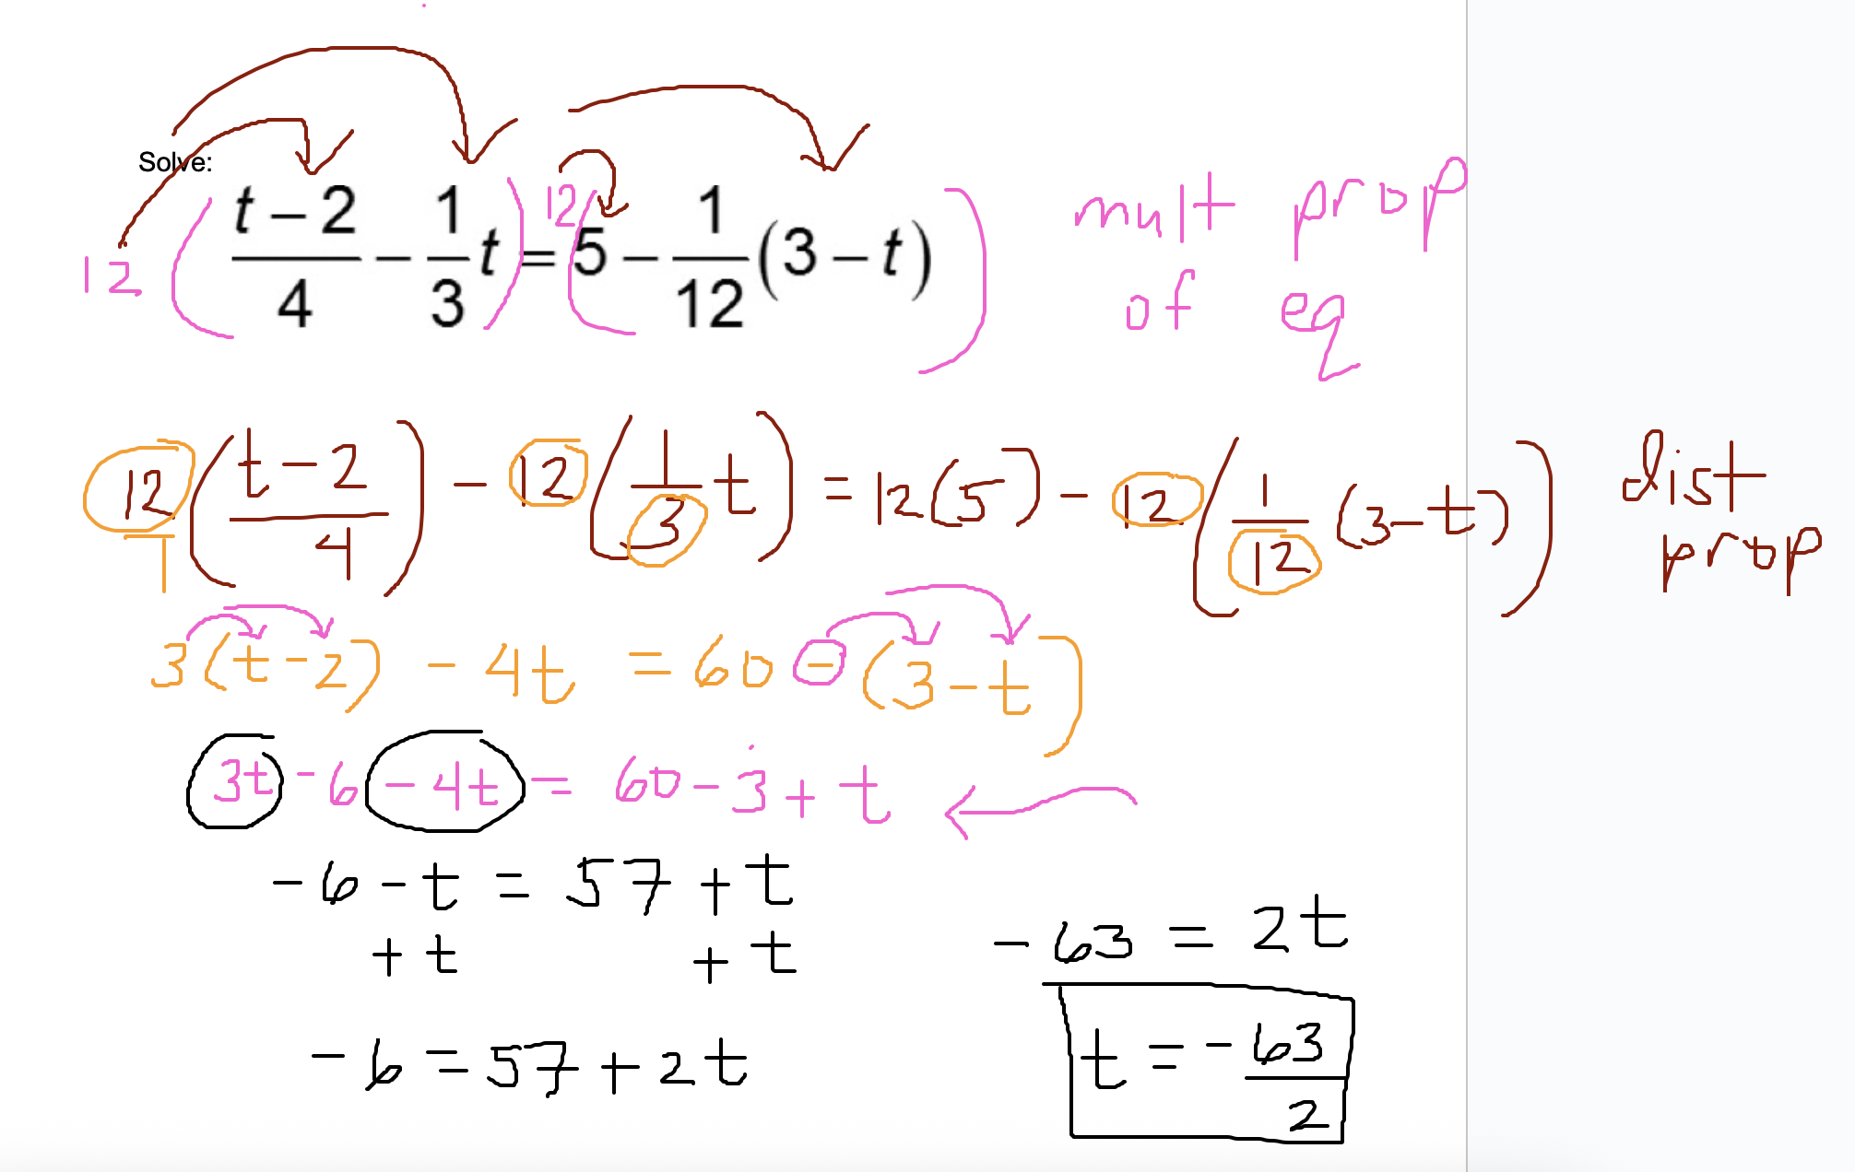

Solve the linear equation: 0.03(z − 3) − 0.5(2z + 1) = 0.23

Using Graphical Tools

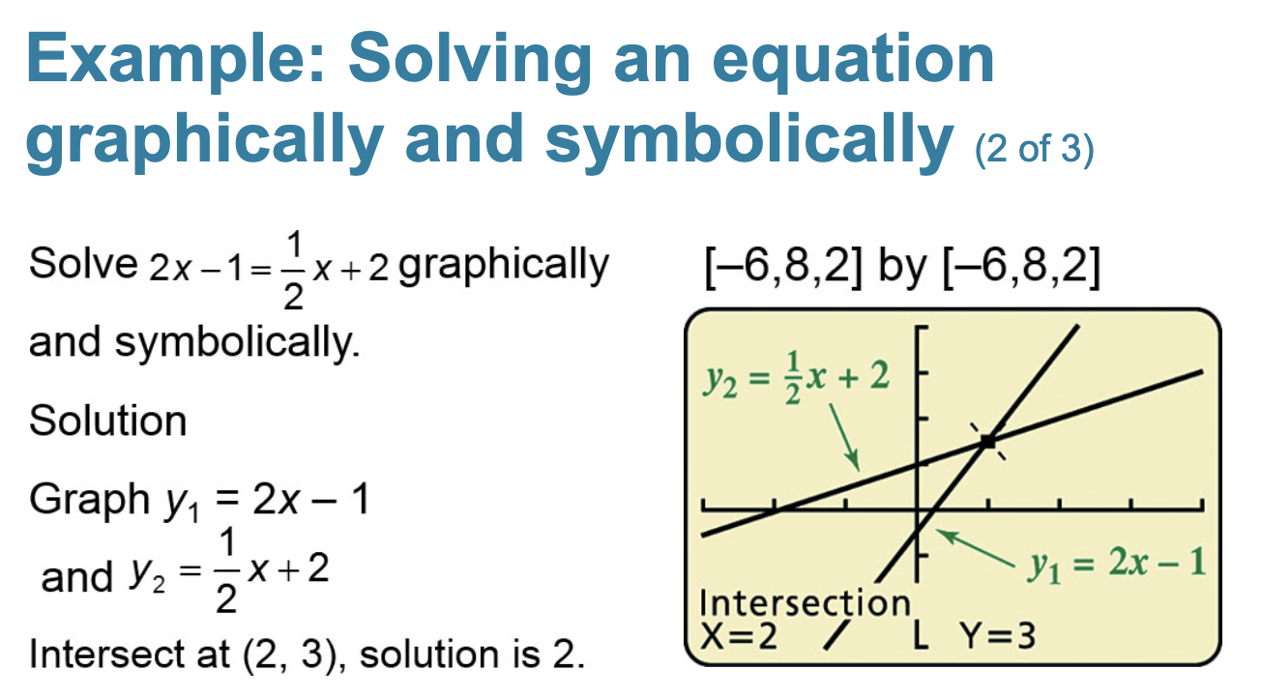
Go to desmos:

Graph y = 2x - 1 and y = 1/2 x + 2. Where do they intersect?

Move everything to one side.

2x - 1 - 1/2 x - 2
Plot the equation y = 2x - 1 - 1/2x - 2
What is the x-intercept?

What can we conclude?

